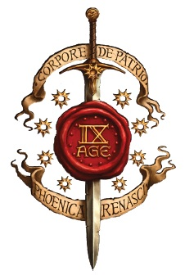
INVASION 12-13 SEPTEMBER 2020
LAG: _______________________________

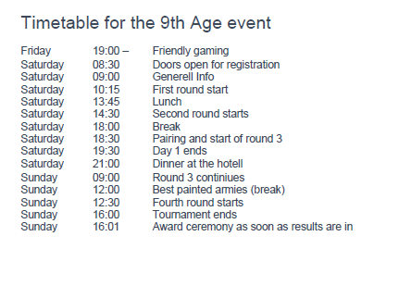
Matching: Første kamp er tilfeldig eller avgjort av grudges. Deretter møter lagene de lagene som har mest mulig likt i poeng. Ingen lag skal møte samme lag to ganger.
Pairing: Denne ble på engelsk gitt. Step 1 - Both Team Captains select one army from their team to put forward to play on table 1 and place the card for this army face down;
1.2. Once both Teams have selected an army, turn the cards face up to reveal which armies are chosen.
1.3. Both Team Captains now select the two remaining armies to face the opposing army.
The armies put forward by each Team are kept secret and revealed at the same time;
1.4. Each Team Captain selects one of the two opposing armies revealed in Step 1.3 to play against the friendly army that they have revealed in Step 1.2. The other army card is taken back into its own Team Captain’s hand, and this army will face the card taken back by the opposing Team Captain. The choice of army is kept secret until both Team Captains have made their choice. This determines the matchups for the round.

Poeng: Hvert slag gir 20 poeng fordelt etter gjeldene regelbok sin fordelingsnøkkel. Poengene summeres til et lagresultat for kampen. Poengene capper på 40-20 de første tre kampene. Fjerde kamp er uten capp.
Scoring ark
Kamp | Spiller |  | Motspiller | Opp. VP* | My VP* | Opp. BP* | My BP*
Bord 1
Bord 2
Bord 3
Sum
* VP 0-4500 (5100), BP 0-20, Score Chart on last page
Capp er 40-20 – ikke før høyere eller laver tall inn i sum
Kamp 2 | Spiller |  | Motspiller | Opp. VP* | My VP* | Opp. BP* | My BP*
Bord 1
Bord 2
Bord 3
Sum
* VP 0-4500 (5100), BP 0-20, Score Chart on last page
Capp er 40-20 – ikke før høyere eller laver tall inn i sum
Kamp 3 | Spiller |  | Motspiller | Opp. VP* | My VP* | Opp. BP* | My BP*
Bord 1
Bord 2
Bord 3
Sum
SUM |  | * VP 0-4500 (5100), BP 0-20, Score Chart on last page Capp er 40-20 – ikke før høyere eller laver tall inn i sum
Kamp 4 | Spiller |  | Motspiller | Opp. VP* | My VP* | Opp. BP* | My BP*
Bord 1
Bord 2
Bord 3
Sum
* VP 0-4500 (5100), BP 0-20, Score Chart on last page
Spilles uten capp

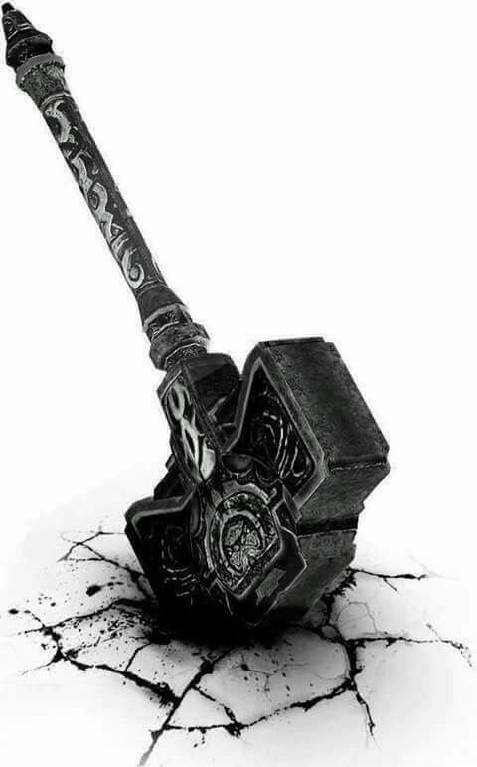
3 Counter thrust
Dawn Assult
1 Frontline Clash
Pre-Game Sequence
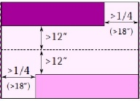
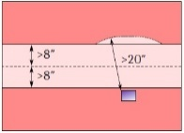
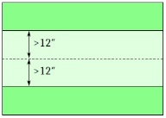
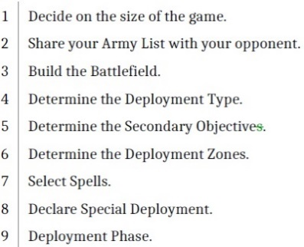

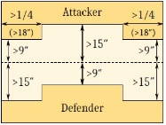
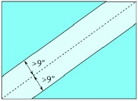
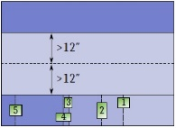
6 Marching column
5 Refused flank
4 Encircle

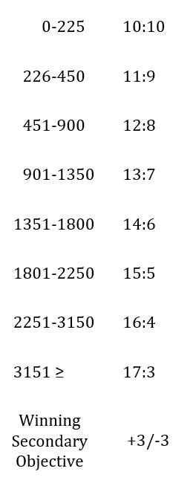
Victory Points Table
Secondary Objectives:

1: Hold the Ground Secure and hold the Battlefield centre. Mark the centre of the board. At the end of each Game Turn after the first, the player with the most Scoring Units within 6″ of the centre of the board gains a counter. At the end of the game, the player with the most such counters wins this Secondary Objective.
2: Breakthrough Invade the enemy territory. The player with the most Scoring Units inside their opponent’s Deployment Zone at the end of the game, up to a maximum of 3, wins this Secondary Objective.
3: Spoils of War Gather precious loot. Place 3 markers along the line dividing the board into halves (the dashed line in the figures describing deployment Types). One marker is placed on a point on this line that is as close as possible to the centre of the board while still being more than 1″ away from Impassable Terrain. The other two markers are placed on points on this line that are on either side of the central marker, as close to the centre as possible but at least a third of the long table edge length (24″ on a standard board) away from it, and more than 1″ away from Impassable Terrain. At the start of each of your Player Turns, each of your Scoring units that is not carrying a marker may pick up a single
marker they are in contact with. Remove the marker from the Battlefield: the unit is now carrying the marker. Units carrying a marker with less than 3 Full Ranks have their March Rate set to their Advance Rate. If a unit carrying a marker is destroyed or loses Scoring (ignore Post-Combat Reform for this purpose), the opponent must immediately place the marker carried by this unit on a point within 3″ of it. This point cannot be within 1″ of Impassable Terrain, but it can be inside a unit. At the end of the game, the player with the most units carrying markers wins this Secondary Objective.
4: King of the Hill Desecrate your opponent’s holy ground while protecting yours. After Spell Selection (at the end of step 7 of the Pre-Game Sequence), both players choose a Terrain Feature that isn’t Impassable Terrain and that is not entirely within their Deployment Zone, starting with the player that chose their Deployment Zone (note that both players may choose the same Terrain Feature). A player captures the opponent’s chosen Terrain Feature if any of his Scoring Units are inside that Terrain Feature at the end of the game. A player wins this Secondary Objective if he captures the opponent’s chosen Terrain Feature while his chosen Terrain Feature is not captured by his opponent.
5: Capture the Flags Valuable targets must be annihilated. After Spell Selection (at the end of step 7 of the Pre-Game Sequence), mark all Scoring Units on both players’ Army Lists. If either player has less than 3 marked units, their opponent must mark enough units from this player’s Army List so that there are exactly 3 marked units in the army, starting with the player that chose their Deployment Zone. The player that has the lowest number of their marked units removed as casualties at the end of the game wins this Secondary Objective.
6: Secure Target Critical resources must not fall into enemy hands. Directly after determining Deployment Zones, both players place one marker on the Battlefield, starting with the player that chose their Deployment Zone. Each player must place the marker on a point that is more than 12″ away from their Deployment Zone and a third of the long table edge length (24″ on a standard board) from the point marked by the other marker.
At the end of the game, the player controlling the most markers wins this Secondary Objective. A marker is controlled by the player with the most Scoring Units within 6″ of the marker. If a unit is within 6″ of both markers, it only counts as within 6″ of the marker which is closest to its Centre (randomise if both markers are equally close).

Objektiver/map
Kamp 1
Bord 1-2 : Hold Ground – refused Flank
Bord 3: King of The hill – Counterthrust

Kamp 2
Bord 1-2 : Breakthrough – Dawn Assult
Bord 3: Capture the Flags - Frontline Clash

Kamp 3
Bord 1-2 : Secure target – Marching Columns
Bord 3: King of The hill – Frontline Clash

Kamp 4
Bord 1-2 : Spoils of War - Encircle
Bord 3: Capture the Flags - Counterthrust

Map Pack:
Map 14 er bord 1
Map 15 er bord 3
Map 16 er bord 2
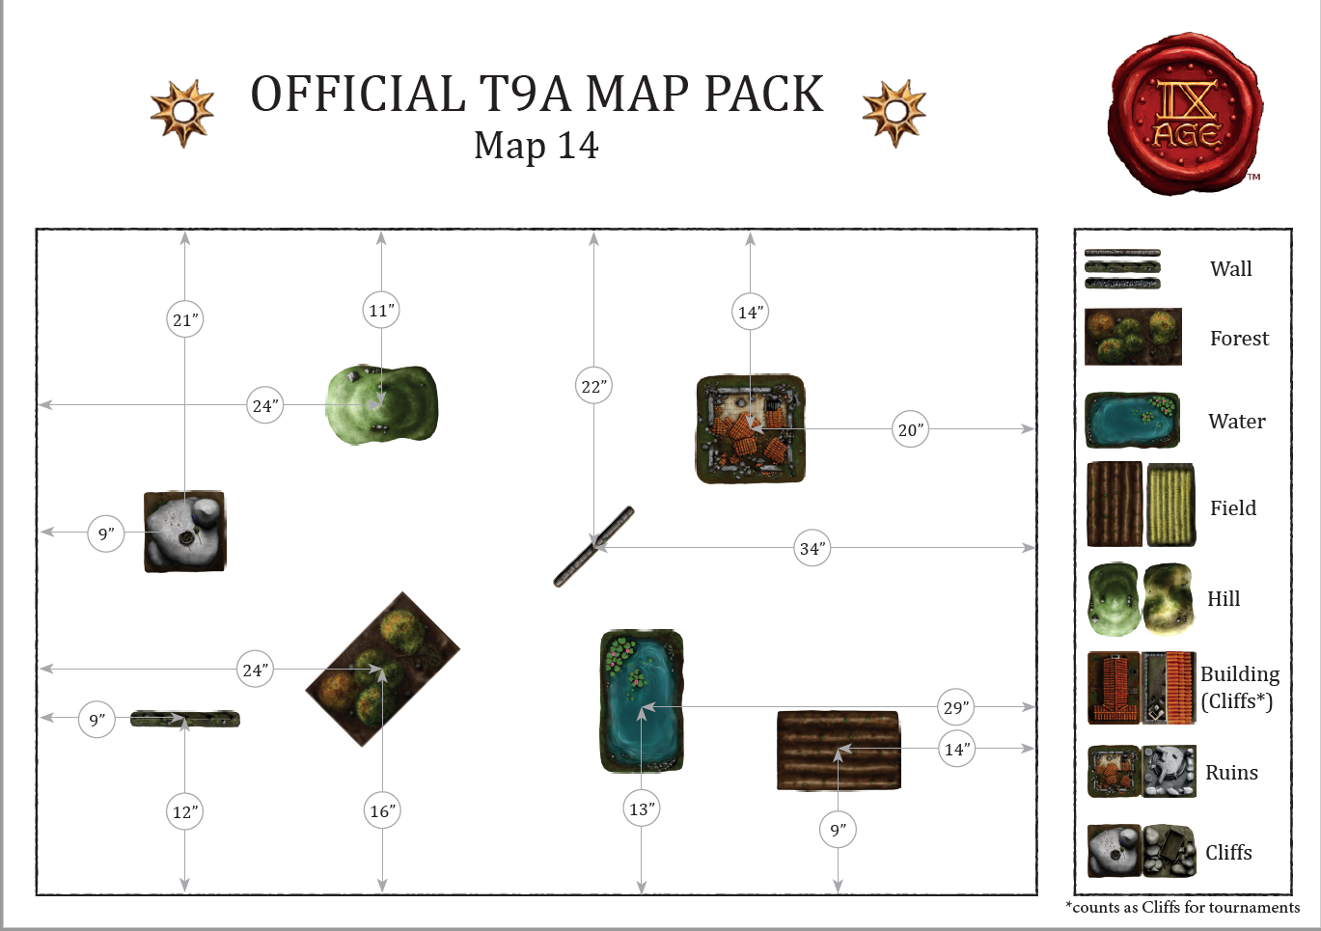
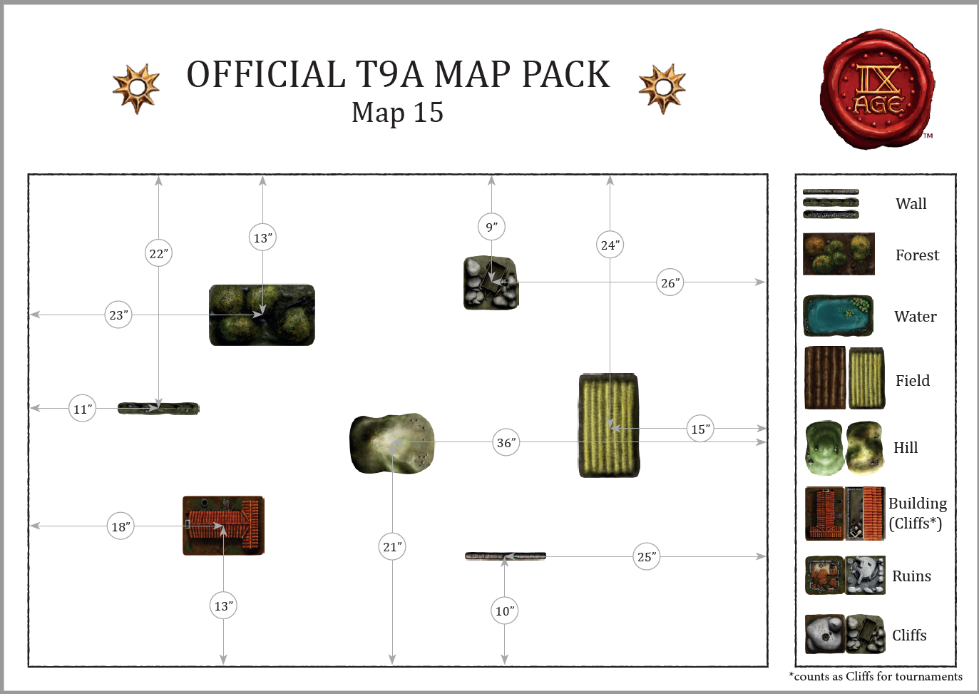
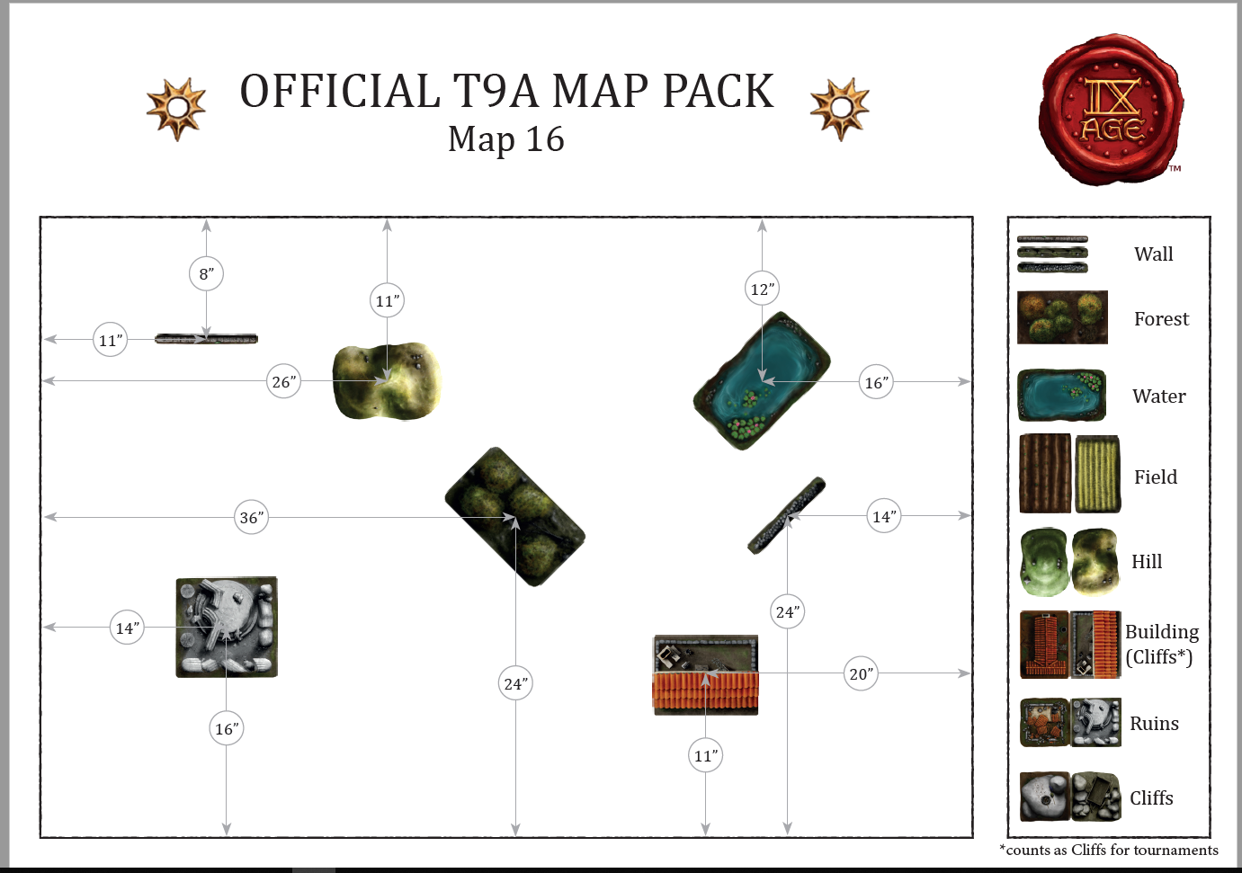
Lister:

Pavesnadder

Sondre Torvund – Infernal Dwarves
360 - Chosen of Lugar, Hero’s Heart, Lugar's Dice, Potion of Swiftness
560 – Prophet, Alchemy/Pyromancy, Army General, Wizard Master, Shield, Alchemist's Alloy, Binding Scroll, Essence of a Free Mind
285 – Vizier, Battle Standard Bearer, Blunderbuss, Shield, Banner of the Relentless Company, Ghostly Guard, Lucky Charm
226 – 17x Infernal Warriors, Shields
790 – 29x Infernal Warriors, Blunderbuss, Great Weapon, Shields, C, S,M
115 – 20x Orc Slaves
514 – 18x Immortals, Great Weapons, S, C, Icon of the inferno
130 – 2x1 Gunnery Team, Flamethrower
600 – 20x Disciples of Lugar, paired Weapons, S,C, Rending banner
450 - Infernal Engine, Shrapnel Guns
335 – 3x Kadim Incarnates
Sum: 4495p

Jørund Haugland – Orcs & Goblins
125 – Goblin Chief, Common Goblin, Battle Standard Bearer, Bow
330 – Goblin King, Forrest goblin, Huntsman Spider, Heavy Armour, Shield, Basalt Infusion, Dusk Forged, heroes Heart
595 – Goblin King, Forrest Goblin, Gargantula, paired Weapons, Shield Breaker
250 – Goblin Witch Doctor, Common Goblin, Wizard Adept, witchcraft, book of Arcane Mastery
500 – Orc Shaman, Common Orc, Army General, Warcry, Wizard Master, Shamanism, paired Weapons, Crown of Autocracy
180 – 20x goblins, Forrest Foblins, Creepers, bows,
180 – 20x goblins, Common Goblins, Bows, Shields, Musician
770 – 30x Orc ‘Eadbashers, Feral orcs, Paired Weapons, S,C,M, Green Tide
360 – 30x Gnasher Herd
372 – 31x Gnasher Herd
120 – 5x goblin Raiders, Common Goblins
198 – 6x Mounted ‘Eadbashers, feral orcs, paired Weapons
150 – Orc Boar Chariot
185 – 2x1 Greenhide Catapults, Git Launcher
Sum: 4500p

Espen Lund – highborn Elves
275 – Commander, Great Weapons, Light Armour, Longbow, Queens Companion, Moonlight Arrows, Binding Scroll
425 – Commander, Battle Standard Bearer, Great Weapon, Light Armour, Longbow, Master of Canreig Tower, Elu's Heartwood
620 – Mage, Army General, Asfad Scholar, Pyromancy, Wizard Master, Binding Scroll, Book of Meladys
260 – 20x Citizen Spears, M
190 – 5x Elein Reavers, Bow
735 – 30x Sea Guard, C, S, M, War Banner of Ryma
713 – 26x Lion Guard, C,M
741 – 27x Lion Guard, C,M
180 – 3x1 Sea Guard Reaper
Sum: 4499p

Fifty Shades of carnage

Martin Hedegaard - OnG
495 - Feral Orc Warlord General, Warboar, Paired Weapons, Light Armor, Shady Shanking, Tuktek's Guard, Pan of Protection Pinchin
270 - Iron Orc Chief Battle Standard, Shield, Willow's Ward, Banner of the Relentless Company
400 - Feral Orc Shaman (Shamanism), Wizard Master, Paired Weapons
635 - Forest Goblin King, Gargantula, Paired Weapons, Shieldbreaker, Troll Ale Flask, Potion of Swiftness.
627 – 24x Feral Orc 'Eadbashers, Paired Weapons, FCG, Banner of the Relentless Company
414 – 11x Feral Orc Boar Riders, Shields, FCG, Banner of Speed
180 – 20x Goblins, Bows, M, Shields
120 – 5x Goblin Wolf Riders
120 – 5x Goblin Wolf Riders
828 – 29x Iron Orcs, FCG, Mikinok's Totem
205 - Git Launcher with Overseer
205 - Git Launcher with Overseer
Sum: 4499p

Sjur Thu - WotdG
700 Chosen lord, General, Envy, Hell-Forged Armour, Shield, Burning Potent, Dusk Forged, Dragonfire Gem, Idol of Spite, Black Steed
335 Sorcerer, Adept, Alchemy, Light Armor, Essence of Mithril, Potion of Strength, Rod of Battle
669 19x Warriors, FCG, Greed, Banner of the Relentless Company
120 - 8x Warhounds
120 - 8x Warhounds
817- 6x Feldraks, Musician, Standard Bearer, Banner of Speed, Halberds
817- 6x Feldraks, Musician, Standard Bearer, Banner of Speed, Halberds
460 - Feldrak Elder, Paired Weapons
460 - Feldrak Elder, Paired Weapons
Sum: 4498p

Karl-Erik “Kalerith” Hansen © DH
520 - King, General, Holdstone, plate armor, shield, Runic Weapon: Ro Smashing+ Destruction+ Fire, Runic Armor: Ro Iron+Forge, Runic Talisman: Ro Shielding x 2
410 – Thane, BSB, plate armor, shield, shield bearers, Runic Armor: Ro Forge, Runic Talisman: Ro Dragons Breath+Shielding, Runic Standard: Banner of Relentless Company
430 - Runic Smith, plate armor, shield, Runic Weapon: Ro Lightening x 3, Runic Armor: Ro Iron x 2, Runic Talisman: Ro Dragons Breath
410 - Runic Smith, plate armor, shield, Runic armor: Ro Iron x 2 + Forge, Runic talisman: Ro Shielding x 2 + Dragons breath
214 - 12. Clan Warriors, heavy armor, shields throwing weapons, musician
197 - 11. Clan Warriors, heavy armor, shields, throwing weapons, musician
733 – 29. Greybeards, heavy armor, shields, FCG, Runic Standard: Ro Swiftness
553 – 22. Seekers, vanguard, musician
553 – 22. Seekers, vanguard, musician
305 - Steam Copter: 2. Attack Copter
175 - Steam Copter 1 Attack Copter
Sum: 4500p

Det Vestlandsfandenivoldske Salmekor

Andreas Furu – Orcs & Goblins
560 - Common Orc Shaman, General, War Cry!, Wizard Master, Shamanism, Crown of Autocracy, Skull Fetish
245 - Common Orc Chief, BSB, Aether Icon, Banner of Discipline, Obsidian Rock
120 - 5 x Forest Goblin Chief, Huntsmen Spider
360 - Forest Goblin Witch Doctor, Wizard Master, Thaumaturg
235 - 3 x 20 Common Orcs, Spears, Musician
215 - 2 x 20 Common Orcs, Spears
288 - 3 x 24 Gnasher Herd
276 - 23x Gnasher Herd
185 - Greenhide Catapult, Git Launcher
185 - Greenhide Catapult, Git Launcher
90 - Skewerer
Sum: 4500p
Hallvard Haugen – Ogre Khans
565 - Shaman, General, Rottenjaw, Wizard Master, Thaumaturgy, Lygur's Tongue
325 - Mammoth Hunter, Iron Fist, Scout, Basalt Infusion, Talisman of Shielding
405 - Mammoth Hunter, Iron Fist, Scout, Trolleater, Wrestler's Belt, Lucky Charm
285 - Mammoth Hunter, Iron Fist, Scout, Karkadan's Resilience
185 - 3x 3 Bruisers
570 - 8 Tribesmen, Iron Fist, Musician, Standard Bearer, Banner of Discipline
175 - 3x Kin-Eater
320 - Thunder Cannon
475 - 2x Rock Aurochs, Hunting Spear
Sum: 4500p
Hermund Furu – Beast Herds
450 - Soothsayer, General, Wizard Master, Shamanism, Crown of Autocracy
360 - Beast Chieftain, BSB, Greater Totem Bearer, Paired Weapons, Aether Icon, Obsidian Rock, Seed of the Dark Forest.
290 - Soothsayer, Wizard Adept, Evocation, Book of Arcane Mastery
140 - 3x 20 Mongrels
160 - 3x 20 Mongrels, Musician
777 - 9 Minotaurs, Shield, Musician
861 - 2x 10 Minotaurs, Shield, Musician
Sum: 4499p

Silverbacks

Hans “stop hitting yourself” Silverback – Daemon legions
985 - Miser of Surlag – Master of Thaumaturgy – Mirrored Scales – Mark of the eternal champion
345 - Harbringer of father chaos General– Adept of Witchcraft – Mirrored scales guiding
430 - Harbringer of father chaos – Adept of evocation Burning Wheel – Mirrored scales guiding
628 - 22 Lemures – Full command – Vennom sacs
260 - 10 lemerus – m – Vennom sacs
240 - 10 Lemerus – mc – Vennom sacs
672 - 6 Bloat flies –c- Unhinged jaw
331 - 3 Bloat flies – Unhinged jaw
235 - 5 Sirens – Hammerhands
195 - 5 Sirens
175 - 5 Hellhounds – Incendiary Ichor
Sum: 4496p

Håkon “Blotting out the sun” Silverback – Sylvain Elves
220 - Druid General Adept Cosmology bow
270 - Druid Adept Shamanism bow Heirloom
320 - Thicket BSB Oaken Crown
285 - 10 Archers Musician
265 - 10 Archers
205 - 5 Heath Hunters
205 - 5 Heath Hunters
205 - 5 Heath Hunters
615 - 6 Thicket beasts Champ
510 - 5 Thicket beasts champ
265 - 8 Sentinels
230 - 7 Sentinels
450 - Treefather
450 - Treefather
Sum: 4495p

Øystein “BomBomBom” Silverback – Ogre Khans
330 - Shaman, General, Adept Pyromancy, Firebrand
345 - Khan, BSB, Mammoth Hide Cloak, Hoardmaster
385 - Shaman, Adept Shamanism, Gut Roarer, Lygurs Tongue, Potion of Strenght
599 - 7x Bruisers, Pennant of the Great Grass Sky, C,M,S
205 - 3x Bruisers, M
155 - 3x Tribesmen
169 - 22x Scraplings, Bow
709 - 6x Mercenary Veterans, Brace of Ogre Pistols, Accurate, Poison, M
205 - 3x Bombardiers, M
205 - 3x Bombardiers, M
80 - 1x Sabretooth Tiger
80 - 1x Sabretooth Tiger
680 - 4x Tusker Cavalry, Banner of Gyengget, M,S
175 - 1x Kin-Eater
175 - 1x Kin-Eater
Sum: 4497p

Ændal og Torshovs Joint Venture

Johan Nereng – Ogre Khans
520 Shaman, General, Master, PW, Rottenjaw, Lygur's Tongue, Shamanism
340 Shaman, Adept, PW, Book of Arcane Mastery, Thaumaturgy
395 Mammoth Hunter, Hunting Spear, Iron Fist, Trolleater, Vanguard, Wrestler's Belt
325 Mammoth Hunter, Hunting Spear, Iron Fist , Vanguard, Basalt Infusion, Talisman of Shielding,
570 8x Tribesmen, MS, Iron Fist, Banner of Dicipline
185 3x3 Bruisers
175 3x Kin-Eater
320 Thundercannon
475 2x Rock Aurochs, Ogre Crossbow
Sum: 4500p

Jarl Magnus – Sylvain Elves
630 Avatar of Nature, General. "Tremann Aldersblad, Hertug av Liljepytt"
445 Druid: cosmology master, sceptre of Power, crystal ball
305 Dryad Ancient: Druidism, Scarred Bark, Wizard Adept
290 Dryad Ancient:, toxic spores, adept divination
130 Dryad Ancient, oaken crown
384 21x Dryads
285 10x archers, musician
195 15x forest guards, musician
285 10x archers, musician
325 5x wild huntsmen, shield
325 5x wild huntsmen, shield,
325 5x wild huntsmen, shield,
240 10x forest rangers, vanguard,
230 7x Sylvan Sentinels
100 forest eagle
Sum: 4494p

Eirik – Vampire Counts
940 Vampire Count, Wizard Adept: Occultism, Monster Hunter, Reaper's Harvest, Zombie Dragon
860 Vampire Count, Army General, The Dead Arise, Wizard Master: Evocation, Arcane Knowledge, Heavy Armour, Shield, Dragonfire Gem, Legend of the Black King, True Thirst, Willow's Ward
105 2x Bat Swarms
133 8x Dire Wolves, Champion
524 32x Ghouls, Champion
150 23x Zombies, Musician
763 32x Barrow Guards, Champion, Musician, Shield, Standard Bearer, Black Standard of Zagvozd
105 3x Great Bats
260 3x Vampire Knights, Musician
660 8x Vampire Spawns, Champion
Sum: 4500p

Oslo Giants

Åsmund -Vermin Swarm
820 - Vermin Daemon, General
335 - Sicarra Assassin, Throwing Weapons, Scurrying Veil, Potion of Swiftness, Lethal Strike
195 - Chief, Battle Standard, Light Armour, Sceptre of Vermin Valour
627 - 59x Rat-at-Arms, Spears, Standard Bearer, Banner of the Endless Swarm, Musician, Champion 245 - 20x Plague Brotherhood, Standard Bearer, Musician
245 - 20x Plague Brotherhood, Standard Bearer, Musician
146 - 21x Giant rats
272 - 14x Plague Disciples
255 - 13x Plague Disciples
255 - 13x Plague Disciples
150 - Meat Grinder
305 - Dreadmill
305 - Dreadmill
170 - Verminous Artillery, Plague Catapult
170 - Verminous Artillery, Plague Catapult
Sum: 4495p

Aslak - SE
730 pts - Forest Prince: General, Titanic Might, Sylvan Longbow, Sylvan Blades, Dragon
360 pts - Chieftain: BSB, Forest Guardian, Hunter's Honour, Willow's Ward, LA, Shield, Elven Cloak, Spear
475 pts - Druid: Master (Shamanism), Binding Scroll, Magical Heirloom, Sylvan Longbow
285 pts - 10 Sylvan Archers: Musician
285 pts - 10 Sylvan Archers: Musician
205 pts - 5 Heath Riders: Heath Hunters
205 pts - 5 Heath Riders: Heath Hunters
150 pts - 8 Dryads
590 pts - 23 Forest Rangers: FCG, Banner of Deception
615 pts - 6 Thicket Beast: Champion
300 pts - 9 Sylvan Sentinels
300 pts - 9 Sylvan Sentinels
Sum: 4500p

Trond - WDG
630 pts - Doomlord: General, Trophy Rack, King Slayer, Gladiator's Spirit, Dusk Forged, Dragonfire Gem, Wyrd Stone, Spiked Shield, Great Weapon
360 pts - Sorcerer: Adept (Occultism), Hero's Heart, Trice-Forged, Plate Armour, Paired Weapon
340 pts - 10 Warriors: C, M, Lust, Halberd
340 pts - 10 Warriors: C, M, Lust, Halberd
120 pts - 8 Warhounds
120 pts - 8 Warhounds
360 pts - Chosen Chariot: Lust
360 pts - Chosen Chariot: Lust
694 pts - 8 Forsworn: FCG, Spiked Shield, Icon of the Infinite
827 pts - 6 Feldraks: FCG, Halberd, Icon of the Infinite
345 pts - Hellmaw: One Ominous Gateway
Sum: 4496p

A fistful of Dice

Eivind Johansen - Undead Dynasties
240 - Nomarch, General, Crown of the Pharaohs, Scroll Desiccation
170 - Tomb Architect, Potiont of strengt
285 - Death Cult Hierarch, Evocation, Book of Arcane Mastery, Hierophant. Adept
495 - Death Cult Hierarch, Divination, Talisman of the Void, Sacred Hourglass, Wizard Master
170 - 20x Skeletons, Spears, Musician
130 - 2x 5x Skeleton Scouts
800 - 8x Skeleton Chariots, Legion Charioteers, Musician.standard bearer, stalker's standard
500 - 5 x Tomb Cataphracts, Musician
500 - 5x Tomb Cataphracts, Musician
760 - 4x Tomb Reapers, Paired Weapons
160 - 2x 1x Sand Scorpion
Sum: 4500p

Jan-Helge Eliassen – Saurian Ancients – A Fistful of Dice
450 - Saurian Warlord, Spear, Heavy Armour, Shield, Glory of the Dawn Age, Tarosaur’s Vigour, Potion of Swiftness
740 - Cuatl Lord, General & BSB, Grasp of the Immortal, Trained from birth, 5 spells, Evocation
350 - Skink Priest, 4 spells, Skink Palanquin, Sun Tablet, Book of Arcane Mastery, Wizard Adept, Druidism
570 - 25 x Saurian Warriors, FCG, Rending Banner
570 - 25 x Saurian Warriors, FCG, Rending Banner
275 - 15 x Saurian warriors, Musician
135 – 2 x 1 Spearback
165 – 1 x Salamander
217 - 3 x Pteradon Sentries, Shields, Fire Bola
239 – 2 x 3 Ramphodon Riders, Shields
415 - Stygiosaur, Mystic Traveller
Sum: 4500p

Tim Aasen - EoS
805 - Imperial Prince, General, Dragon, Potion of Swiftness (10)
255 - Marshal, Shield, Crown of the Wizard King (Cannot be taken by Wizards) (50), Obsidian Rock (25), Shield, Battle Standard Bearer, Aether Icon
545 - Wizard, Light Armour, Shield Breaker (40), Destiny's Call (Standard Size models only) (70), Potion of Strength (10), Locket of Sunna (70), Light Armour, Wizard Master, Pyromancy
125 - Wizard, Divination
465 - 46x Heavy Infantry, Champion, Musician, Standard Bearer
150 - 10x State Militia Irregulars
150 - 10x State Militia Irregulars
265 - 20x Light Infantry, Handgun (4+), Handgun (4+)
145 - 20x Heavy Infantry support unit
200 - Mortar
250 - Cannon
326 - 3x Knights of the Sun Griffon, Lance (3), (3)
326 - 3x Knights of the Sun Griffon, Lance (3), (3)
200 - 15x Flagellants
200 - 15x Flagellants
90 - 5x Imperial Rangers
Sum: 4497p

Sørlandslauget For Salig Sodomi og Syndige Salmer
Thomas Nilsen - Daemon Legions
815 - Sentinel of Nukuja, General, Thaumaturgy, Brimstone Secretions, Kaleidoscopic Flesh, Mark of the Eternal Champion, Segmented Shell
265 - 10 x Imps, C, Mark of the Eternal Champion
265 - 10 x Imps, C, Mark of the Eternal Champion
627 - 22 x Myrmidons, C, S, M, Piercing Spike
716 - 5 x Brazen Beasts, C, S, M, Red Haze
205 - 5 x Eidolons, Aura of Despair
205 - 5 x Eidolons, Aura of Despair
205 - 5 x Eidolons, Aura of Despair
445 - 1 x Hope Harvester, Engine of Damnation, Aura of Despair
300 - 4 x Mageblight Gremlins, Venom Sacs
225 - 1 x Titanslayer Chariot, S
225 - 1 x Titanslayer Chariot, S
Sum 4498p

Kristian - Vampire Cunts
285 - Barrow King, Battle standard Bearer, Lucky Charm, Basalt Infusion, Willow's Ward
430 - Nercromancer, Wizard Master, Evocation, Necromantic Staff
1060 - Vampire Count, General, Arcane Knowledge, Wizard Adept, Occultism, Paired Weapons, Touch of Greatness, Obsidian Rock, Zombie Dragon, Colossal Zombie Dragon,
88 - 8 x Dire Wolves, C
612 - 36 x Ghouls, C
180 - 25 x Zombie, M, S
775 - 30 x Barrow Guard, Halberd, C, M, S Black Standard of Zagvozd
190 - 5 x Spectral Hunters
260 - 3 x Vampire Knights, M
260 - 3 x Vampire Spawn, C
335 - 1 x Varkolak
Sum: 4500p

John Rune - Dwarfs
185 - Anvil of Power
365 - Dragon Seeker, Monster Seeker, 2 x Rune of Fury, Rune of Quickening
585 - King, General, Pistol, Shield Bearers, Rune of Craftsmanship, Rune of Destruction, Rune of Fury, Rune of Iron, Rune of Steel, Rune of the Forge
295 - Runic Smith, 3 x Battle Runes, Shield, 2 x Rune of Iron, Rune of the forge,
350 - Thane, Battle Standard Bearer, Holdstone, Shield, 2 x Rune of Iron, 3 x Rune of Lightning
690 - 40 x Clan Warriors, Great Weapon, C, M, S
639 - 36 x Clan Warriors, Shield, C, M, S, Banner of the Relentless Company
265 - 10 x Miners, Paired Weapons, Throwing Weapons, M
223 - 8 x Seekers, Skirmish, Vanguard, C
130 - 1 x Vengeance Seeker
305 - Steam Copters, Attack Copter, Additional Copter
255 - Cannon
210 - Catapult
Sum: 4498p

Team Skausau
Sigbjørn “Ugrush” Eriksrud - WDG
675 - Chosen Lord of Envy on War Dais, General, Trophy Rack, GW (Blessed Inscriptions), HFA (Gladiator’s Spirit), Talisman of Shielding, Obsidian Rock, Aether Icon, Luck of the Dark Gods
615 – Sorcerer, 4 spells, Wizard Master of Evocation, PA, Ledger of Souls, Binding Scroll, Veil Walker
395 – Sorceror on Dark Chariot, 2 Spells, Wizard Adept of Alchemy, PA, PW (Hero’s Heart), Lucky Charm, Dragonfire Gem
315 – Barbarian Chief in Dark Chariot, PW (Shield Breaker), HA (Basalt Infusions), Shield
450 – 31 Barbarians, FCG, Spears and Shields, Banner of Speed
210 – 20 Barbarians, Musician, Shields
120 – 2x8 Warhounds
799 – 2x6 Feldraks, PW, Musician, Standard, Banner of Speed
Sum 4498p
Mads “Anerini” Lund – KoE
755 – Grail Duke on Hippogryph, General, Lance (Divine Judgement), Shield (Fortress of Faith), HA (Basalt Infusions), Potion of Swiftness, Lucky Charm
385 – Damsel on Barded Warhorse, Wizard Master of Shamanism
370 – Questing Paladin, BSB, Shield (Willows Ward), Obsidian Rock, Flaming Standard, Aether Icon
320 – 6 Knights of the Realm, FCG
320 – 6 Knights of the Realm, FCG
250 – 5 Knights Aspirants, Musician
250 – 5 Knights Aspirants, Musician
130 – 5 Yeomen Outriders, Shields
130 – 5 Yeomen Outriders, Shields
750 – 28 Knights Forlorn, FCG, Banner of Speed
834 – 9 Knights of the Grail, FCG, Banner of Roland
Sum 4494p
Arne “Aeron” Sverdrup-Thygeson – BH
610 – Beast Lord on Razortusk Chariot, General, Hunting Call, Beast Axe (Fatal Folly), HA (Basalt Infusions), Shield, Dark Rain, Talisman of Shielding
350 – Beast Chieftain, BSB, Greater Totem Bearer, Beast Axe, LA (Essence of Mithril), Dragonfire Gem
495 – Soothsayer, Wizard Master of Druidism, Binding Scroll, Seed of the Dark Forest
95 – 10 Mongrel Raiders
602 – 41 Wildhorn Herd, PW, FCG, Banner of the Wild Herd
220 – 15 Wildhorn Herd, TW, FCG, Ambush
220 – 15 Wildhorn Herd, TW, FCG, Ambush
120 – Briar Beast
185 – 5 Centaurs, TW
80 – 5 Feral Hounds
185 – 10 Longhorn Herd, Musician, Ambush
185 – 10 Longhorn Herd, Musician, Ambush
100 – Razortusk Herd
100 – Razortusk Herd
475 – Gortach
475 – Gortach
Sum: 4497p

Dronning Margretes Drenger

Marius Brunborg – Daemon Legions
700 - Chosen Lord, Army General, Favour of Nukuja, Goddess of Sloth, Halberd, Luck of the Dark Gods, Trophy Rack, War Dais, Basalt Infusion, Talisman of Shielding, Touch of Greatness, Zealots Banner
550 – Sorcerer, Evocation, Veil Walker, Wizard Master, Destiny's Call - Standard Size only, Veilgate Orb
180 – 4x1 Barbarian Chief,Shield, Spear, Throwing Weapons (4+), War Dais
350 – 2x 20 Barbarian, Musician, Spear and Shield, Standard Bearer, Throwing Weapons (5+), Banner of the Relentless Company
218 – 16 Barbarians, Paired Weapons, Standard Bearer, Banner of the Relentless Company
335 - Battleshrine, Ledger of Souls
335 – 2x 5Warrior Knights,Favour of Vanadra, Goddess of Wrath, Favoured Champion, Great Weapon, 5x Warrior Knight
300 – 2x1 Marauding Giant, Tribal Warspear
Sum: 4498p
Lasse – Beast Herds
705 - Minotaur Warlord, Army General, Paired Weapons, Aaghor’s Affliction, Blessed Inscriptions, Crown of Horns, Potion of Swiftness
460 - Minotaur Chieftain, Battle Standard Bearer, Greater Totem Bearer, Paired Weapons, Hero's Heart, Wildform
380 – Soothsayer, Shamanism, Special Equipment, Wizard Master
378 – 36 Mongrel Herd, Musician, Spears, Standard Bearer, Banner of the Wild Herd
95 - Mongrel Raiders
220 – 2x15 Wildhorn Herd, Ambush, Musician, Throwing Weapons
258 – 2x6 Centaur, Lance, Musician
150 - 5 Gargoyles, Scout
630 – 6 Minotaurs, Musician, Shield, Standard Bearer, Banner of Speed, Totem Bearer: Black Wing Totem
230 - Razortusk Chariot
410 - 6 Razortusk Herd
100 - Razortusk Herd
Sum:4494p
Andreas – vermin Swarm
820 - Vermin Daemon, Army General
250 - Chief, BSB, Binding Scroll, Sceptre of Vermin Valour
725 - Plague Patriarch, LA, Plague Flail, Plague Pendulum, Wizard Adept, Putrid Protection
140 – 2x10 Footpads, Musician
140 - 20 Giant Rats
200 – 2x30 Giant Rats
305 - 24 Plague Brotherhood, FCG,
90 - 2 Rat Swarms
540 - 7 Vermin Hulks, C
305 – 2x1 Dreadmill
170 – 2x1 Verminous Artillery, Plague Catapult
Sum: 4500p

